Project Planning Phase Milestone and Activity List

|  |  |
| --- | --- |
| **Date** | 29 October 2022 |
| **Team ID** | PNT2022TMID02292 |
| **Project Name** | Early Detection of Chronic Kidney Disease Using Machine Learning |

Milestone and Activity List:

|  |  |  |
| --- | --- | --- |
| **TITLE** | **DESCRIPTION** | **DATE** |
| **Literature Survey & Information Gathering** | Literature survey on the selected project & gathering information by referring the, technical papers ,research  publications etc. | 17 SEPTEMBER 2022 |
| **Prepare Empathy Map** | Prepare Empathy Map Canvas to capture the user Pains & Gains, Prepare list of  problem statements | 17 SEPTEMBER 2022 |
| **Ideation** | List the by organizing the brainstorming session and prioritize the top 3 ideas based on the feasibility &  importance. | 17 SEPTEMBER 2022 |
| **Proposed Solution** | Prepare the proposed solution document, which includes the novelty, feasibility of idea, business model, social impact, scalability of solution,  etc. | 02 OCTOBER 2022 |
| **Problem Solution Fit** | Prepare problem - solution fit document. | 02 OCTOBER 2022 |

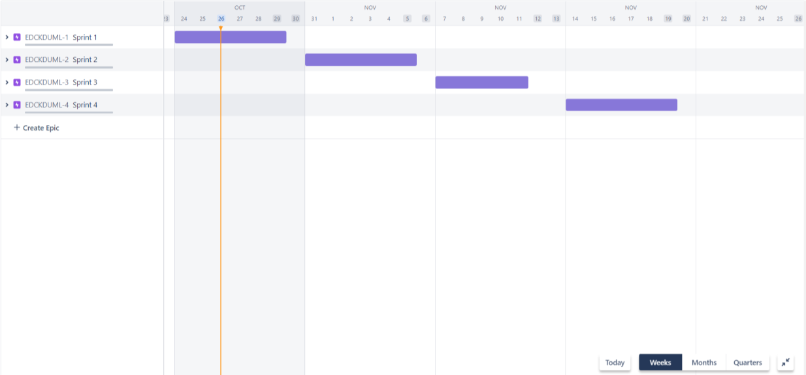

|  |  |  |
| --- | --- | --- |
| **Solution Architecture** | Prepare solution architecture document. | 02 OCTOBER 2022 |
| **Customer Journey** | Prepare the customer journey maps to understand the user interactions & experiences with the application. | 17 OCTOBER 2022 |
| **Data Flow Diagrams** | Draw the data flow diagrams and submit for review. | 17 OCTOBER 2022 |
| **Technology Architecture** | Architecture diagram. | 19 OCTOBER 2022 |
| **Prepare Milestone & Activity List** | Prepare the milestones & activity list of the project. | 29 OCTOBER 2022 |
| **Project Development -**  **Delivery of Sprint-1, 2, 3**  **& 4** | Develop & submit the developed code by testing it. | IN PROGRESS |